REPORT OF SEEFOR PROJECT - CITIZENS’ FEEDBACK
MAY - DECEMBER 2020
1.0 BACKGROUND INFORMATION:
SEEFOR (State Employment and Expenditure for Results): This is a youth employment project operating in four states of the Niger Delta (Edo, Delta, Bayelsa and Rivers). It has built 905 rural roads and engaged youth for the sweeping and cleaning of 402 urban roads around 1,307 community projects. Similarly, 378 community development plans consisting over 600 community micro projects as basic social facilities (classrooms, water supply, health clinics, electricity supply, socio-economic and rural roads) were implemented. More so, SEEFOR project has supported 2247 FADAMA User Groups in the areas of crop production, fishery, livestock, poultry, processing, forestry and market infrastructure. Again, 385 Technical Vocational and Agricultural institutions were supported by the project with laboratory and workshop materials/equipment, while others were renovated or constructed.
2.0 CITIZENS’ FEEDBACK MECHANISM:
In the second quarter of 2019, SEEFOR project has digitized over 4000 project locations from August to October 2019 using KoBoToolbox – the standard App used by the Bank globally that was developed by Harvard University. Each State formed its own team, received training and travelled to various project locations. They have created an online GIS database with photographs, basic project data and GPS coordinates. Quality control was strictly monitored during the process and teams had to return to project locations if the data quality was not of the required standard. This is in the public domain (it is available at www.kobotoolbox.com on the researchers/everyone else login with the followings login credentials Username: seefornpcu_monitoring_client; Password: NPCUCLIENT). Project locations show up on the GIS map and citizens can provide feedback through Kobo on what the status is regarding that projects.
In view of the above, SEEFOR Project planned and organized stakeholder meeting in two states (Rivers and Bayelsa) as a pilot stage between 5th and 10th December 2019 to conduct a Pilot Citizens’ Feedback. Those in attendance during the meetings were staff from the Federal Ministry of Finance, NPCU, KoBo Consultant, SPCU and relevant State MDA desk officer. After long discussion and deliberations in each State, citizens’ feedback questionnaire was developed and agreed to be publicized for citizens’ engagement in each State. The followings were adopted as mechanism for the deployment of citizens’ feedback; major communications campaign in each state using social media, local radio stations and short videos clips to inform citizens and to solicit feedback through Kobo on the performance of these implemented projects. The feedback was ran in all the region from May 2020 to July 2020 and monitored by the KoBoToolbox Coordinators viz. Engr Mustapha Abdullahi, and the PC’s of each state. The PC’s will take responsibility for providing feedback to the citizens on the issues raised by them and keep Engr Mustapha informed.
3.0 INDICATORS AND REPORT ANALYSIS:
During the meetings held in two states, the following indicators were adopted for rolling out as template for citizens’ feedback;
- State, LGA, Project Component and Project Description (Name of Project) as an introduction part to know from which location is the complaint, grievance or commendation coming, while the main part contains;
- Status of project – whether the project is ongoing, completed or abandoned, after selecting any option above, then a follow-up questions will pop-up; ongoing – level of work done so far; completed – Is it functional or not-functional; abandoned – reason(s) for abandoned project (you can respond to the following options – inflation, conflict, militancy, insecurity, flood and oil spillage).
- Do you face any challenge(s) – with options yes or no. If yes is selected, depending to the project component selected above many options will pop-up for respondent to select.
- Picture of project and GPS Coordinate – this is the concluding part of the template; the respondent can send picture of the project and get the GPS automatic.
The activities kick-started in Bayelsa State on the 8th May 2020, then subsequently followed by Delta State on 13th May 2020, Rivers State on 23rd May 2020 and Edo State on 13th July 2020. Edo State started late because during that period there was a pilot ground truthing of SEEFOR Projects being undertaken by Data Science Nigeria (DSN) Lagos.
3.1 Respondent Response by State:
From starting period to the closing date of SEEFOR Project in September 2020 a total of 1,785 submissions were received in the database, but 228 submissions were recorded without States or LGA selected by the respondent. Therefore, 1557 submissions were recorded with States by the respondents; There are 552 submissions from Rivers State, 498 submissions from Bayelsa State, 490 submissions from Delta State and 14 submissions from Edo State, while each state has corresponding percentage of 30.92%, 27.9%, 27.45 and 0.95% respectively.
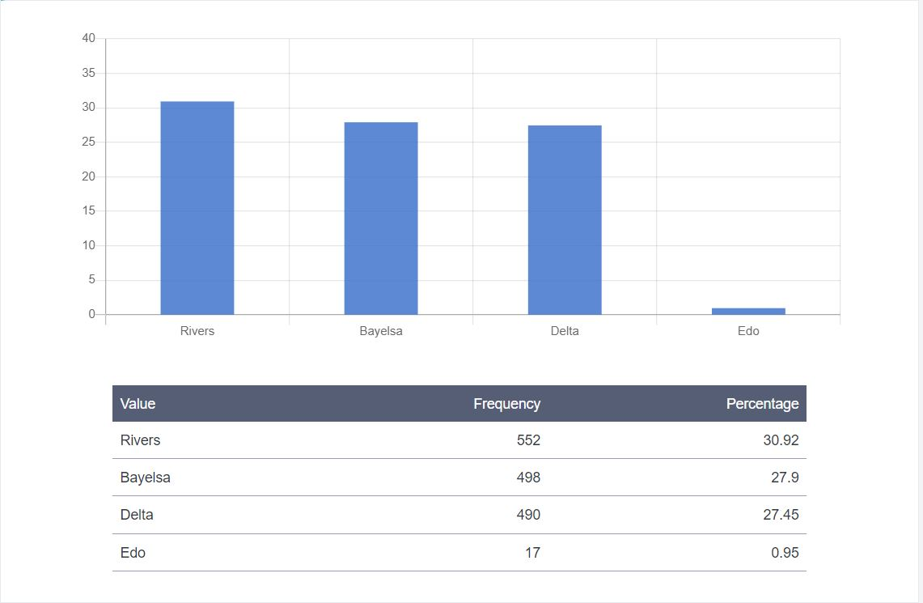
Fig. 1: Submissions according States by Respondent
3.2 Submission from Respondent by Project Component:
The template was designed in such a way that the respondent can select a project component to respond on it, the projects as four (4) sub-components namely; Public Works (Road Maintenance), CDD Economic (FADAMA Projects), CDD Social (CSDA Projects) and TVEAT (Technical Vocational Institution). CDD Social has the highest responses with 482 submissions (27%), then followed by Public Works with 452 submissions (25.32%), CDD Economic with 433 submissions (24.26%) and lastly TVEAT has 125 submissions (7%).
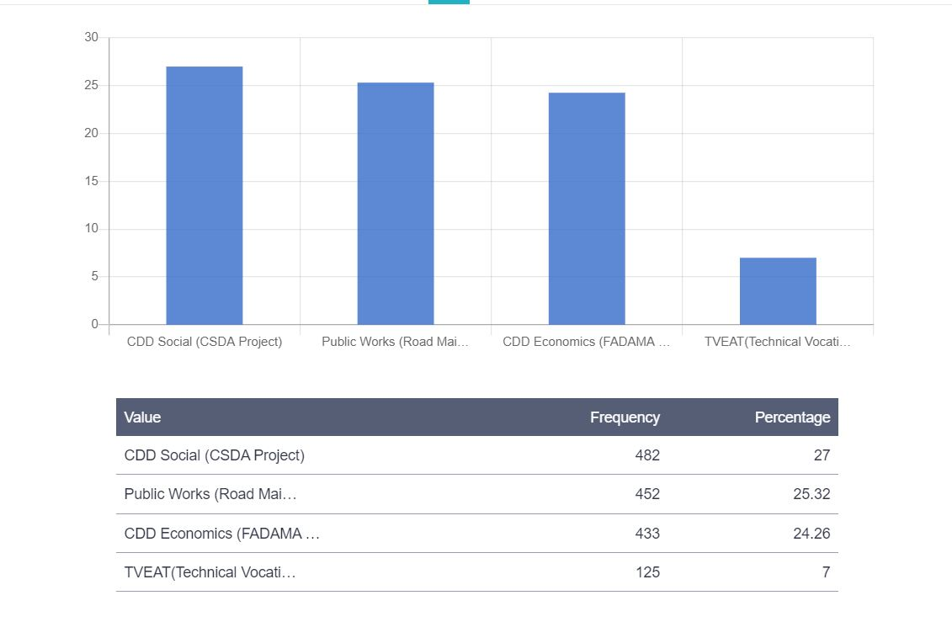
Fig. 2: Submissions according Project Component by Respondent
3.3 Status of Project:
The respondents were allowed to respond on the status of project that they were responding on, this would inform the project team on the current position or stage of the project implementation. About 77.98% of respondents responded that the 1,392 projects were completed and out of that number 73.39% were functional, while 2.13% were not functional. Similarly, 6.95% of respondents responded that 124 projects were ongoing at various stages of implementation. Also, 1.09% of the respondents reported that 18 projects were abandoned by the contractor or the benefitting community’s due to inflation and conflict. Figure 3, 4 and 5 shows the status of project, functionality and reasons for abandoning some projects.
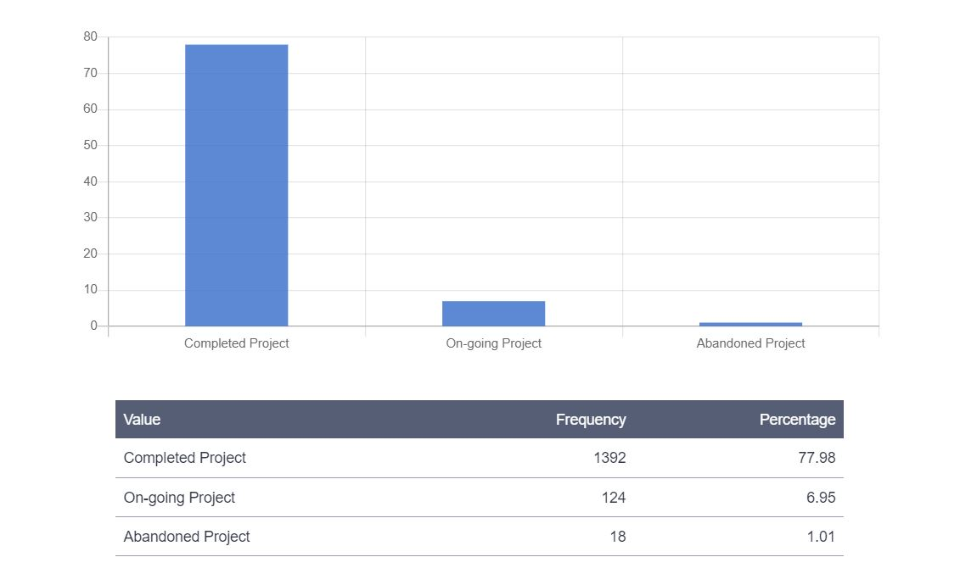
Fig. 3: Status of Projects

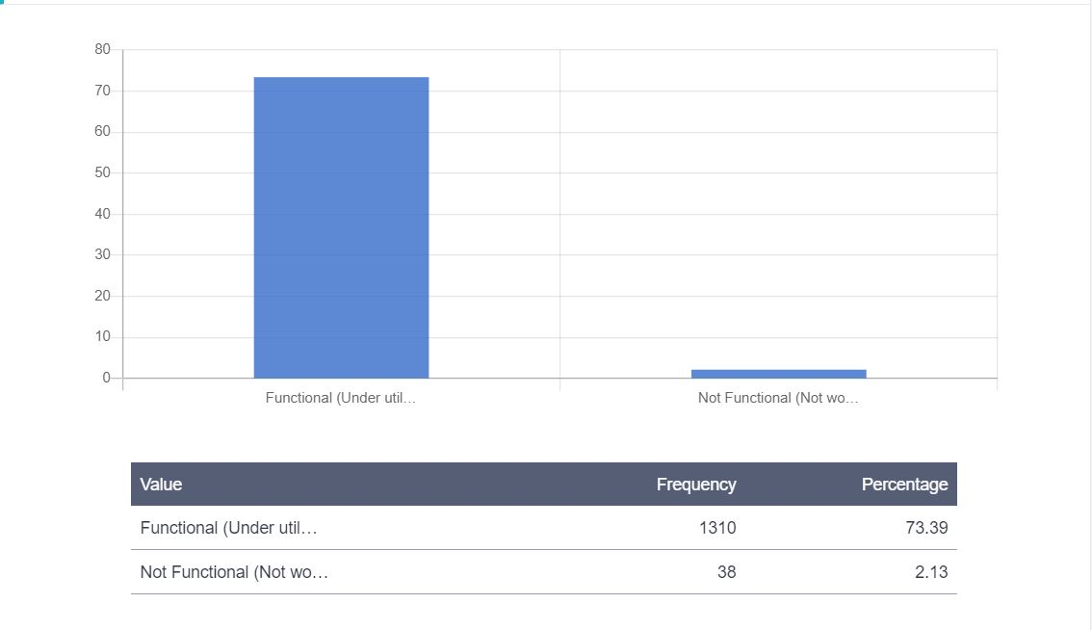
Fig. 4: Functionality of Projects
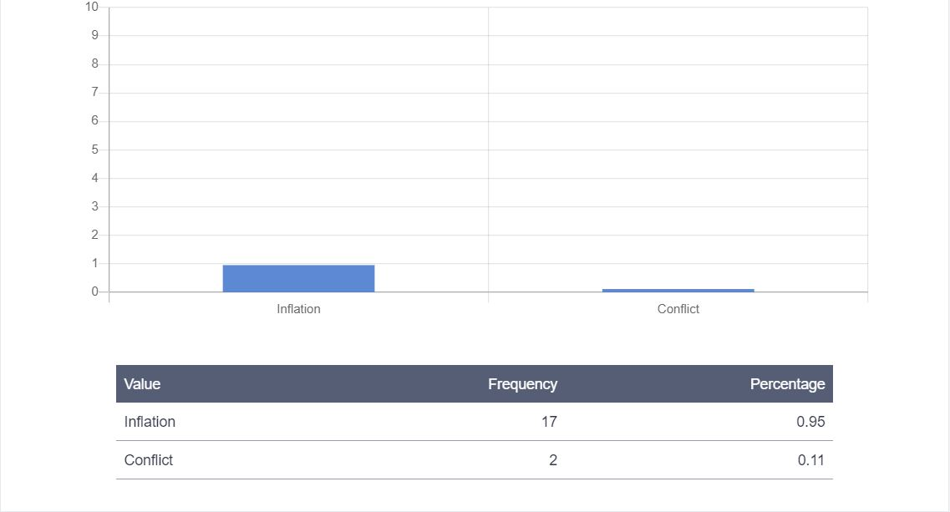
Fig. 5: Projects Abandoned due to Inflation or Conflict
3.4 Challenges face during implementation:
This indicator seeks to know from the beneficiaries the challenges they faced during project implementation by contractor or community members. The indicator has two options yes or no and the respondent can only select one option at a time. However, if the response is yes, then a follow-up indicator will appear depending on the project sub-component selected by the respondent at the beginning of the template.
This indicator has a total 1,537 responses and 68.8% responded with ‘no’, while 17.31% responded with ‘yes’. Therefore, only 309 respondents responded that they faced challenges during implementation or after implementation.
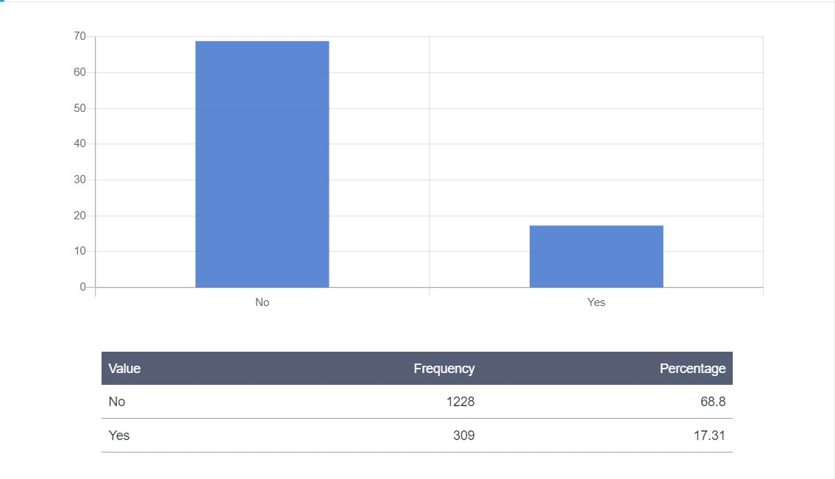
Fig. 6: Number and Percentage of Responses on whether you face any challenge

About 33 respondents reported that they faced challenges during and after implementations, the challenges are inflation, insufficient fund from implementing Agency, conflict, insecurity and flooding with 0.62%, 0.5%, 0.34%, 0.22% and 0.17% respectively. The figure below show the percentage and number of respondents that reported on challenges.
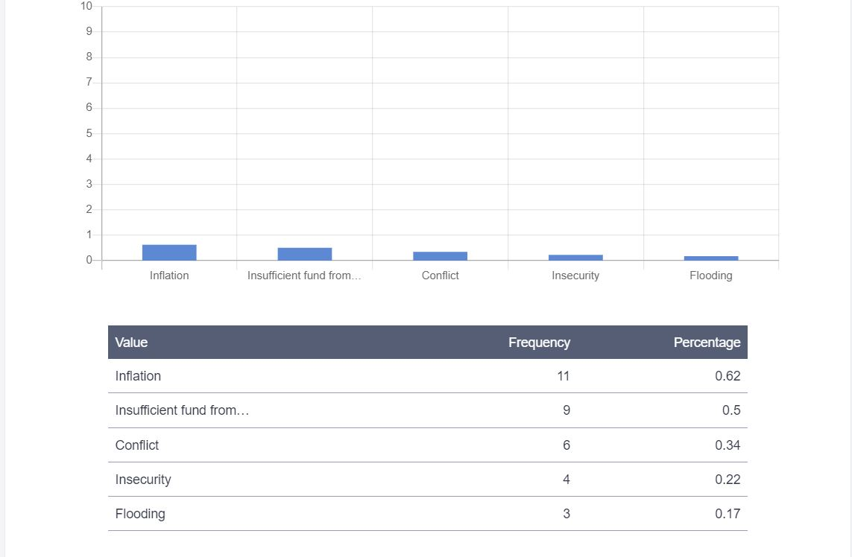
Fig. 7: Type of challenge faced during or after implementation

3.5 Challenges faced by Project Sub-Component:
This are the challenges faced by respondents during implementation under different projects sub-components.
- Public Works (Road Maintenance) beneficiaries; Here a total of 92 beneficiaries responded on challenges faced, the challenges are; Pot-hole on the road/walk-way; No side-drain resulting in flooding of road/walk-way; Dirty street/culvert; Refuse point/bin over-flooded; No show-up by workers for waste collection/cleaning; and Inflation. Figure 8 below show the responses by percentage.
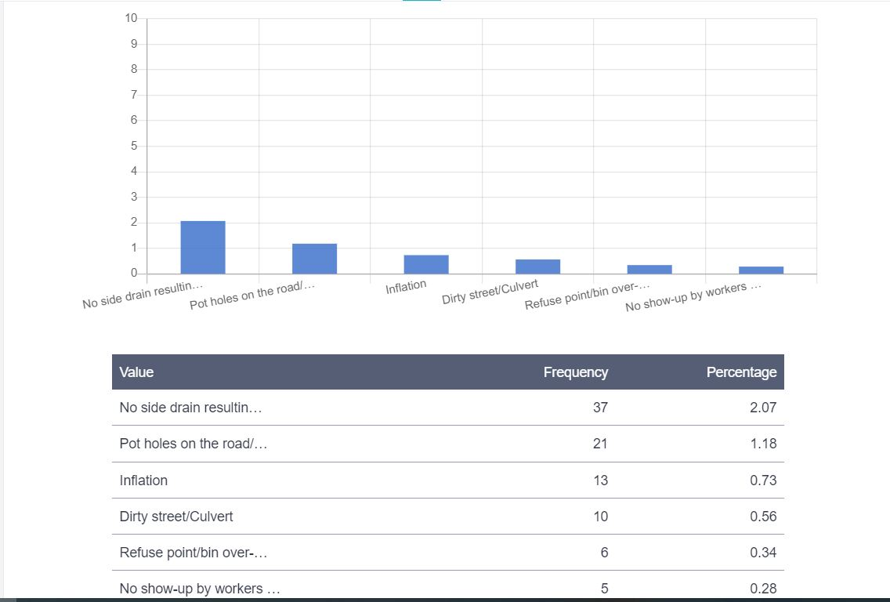
Fig. 8: Response by Public Works Beneficiaries

- CDD Social (CSDP Projects) beneficiaries: A total of 31 beneficiaries responded on challenges faced, the indicator are; Insufficient fund from the community; Inflation; Leadership conflict; Electricity installation vandalized or faulty; Civic center/Town hall/Market shop/Recreational center dilapidated; Borehole/Handpump faulty; and Classroom/Health center/Quarters dilapidated.
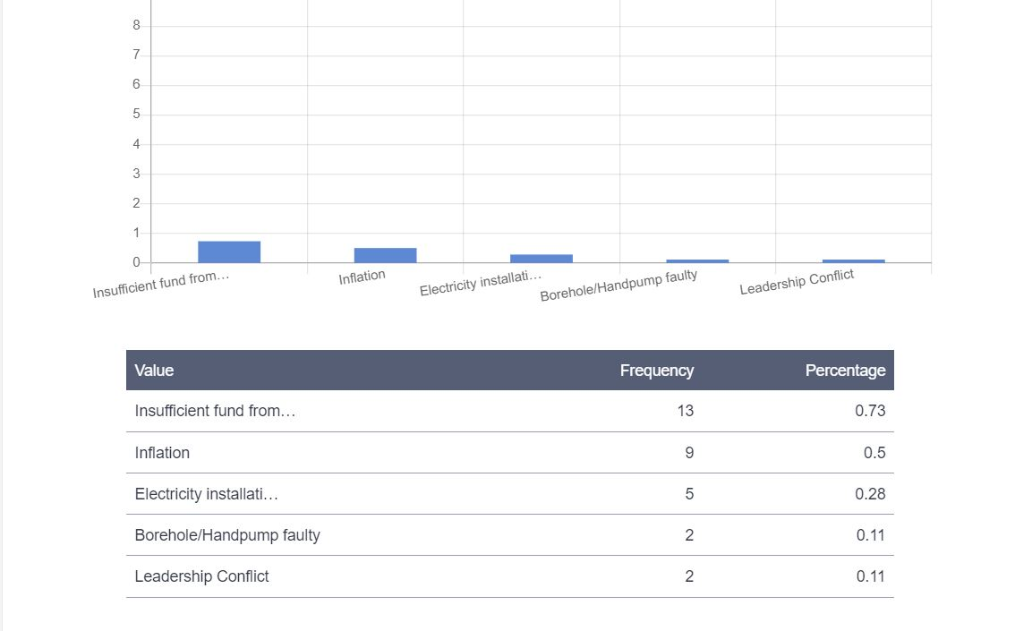
Fig. 9: Response by CDD Social Beneficiaries
- CDD Economic (FADAMA Projects) beneficiaries: A total of 115 beneficiaries responded on this and the indicators are; Conflict; Flooding; Oil spillage; Militancy; and Inflation.
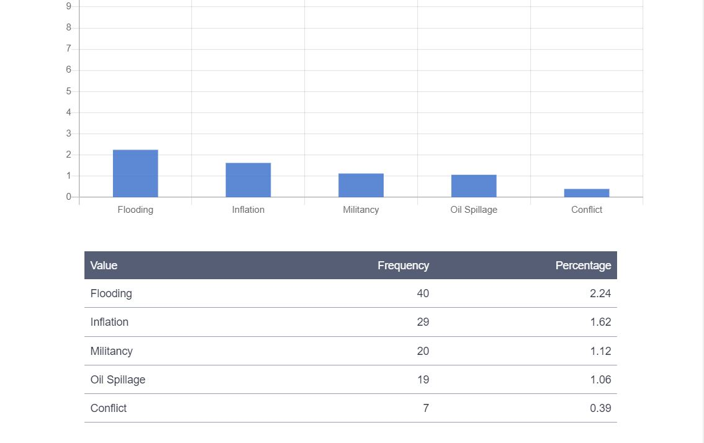
Fig. 10: Response by CDD Economic Beneficiaries
- TVEAT (Technical Vocational Institution) beneficiaries; A total of 30 beneficiaries responded on this and the indicator are; incomplete supply of equipment; Insufficient starter packs; and Workshop building dilapidated.
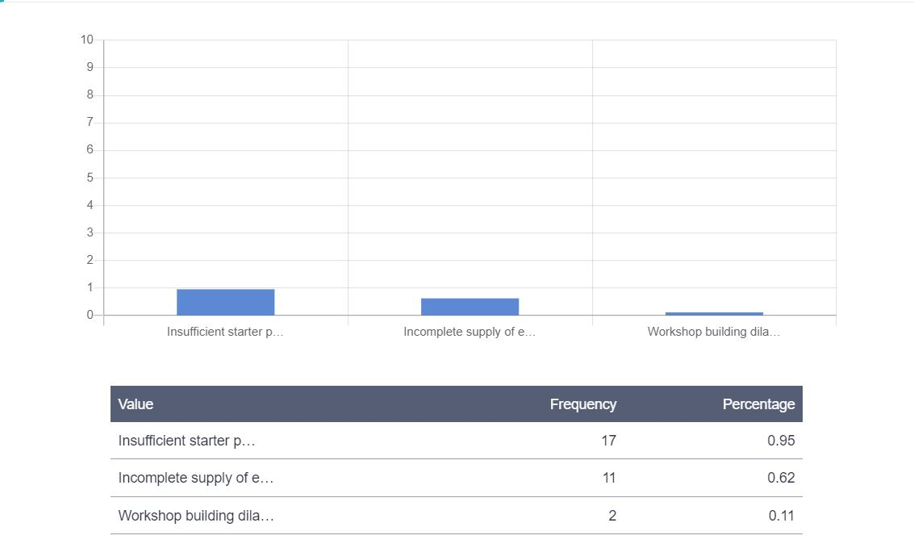
Fig. 11: Response by TVEAT Beneficiaries

